Scientific Notation  Handout-Answers | Name:  Date:
Objective:
- Conversion between Standard Decimal and Scientific notation
- Using the Properties of Exponents to Perform Operations with Scientific Notation

Segment 1: we use two types of notation to write numbers: decimal notation and scientific notation.

Definition

A number in scientific notation is written using the times symbol in the form
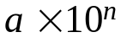
where 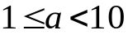 and n is an integer.

Segment 2: Converting Scientific Notation to Standard Decimal Notation
- Determine the number of places to move the decimal point by examining the exponent on the 10.
- Move to the right for a positive exponent and to the left for a negative exponent.

Example 1 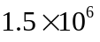 = 150,0000
Example 2 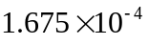 = 0. 0001675
Converting Standard Decimal Notation to Scientific Notation
- Count the number of places (n) that the decimal must be moved so that it will follow the first nonzero digit of the number.
- If the original number was larger than 10, use 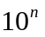.
- If the original number was smaller than 1, use 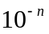.

Example 3 980,000,000 = 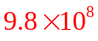
Example 4 0.0000000000753 kg =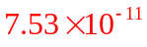
Practice 1 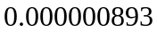=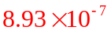
Practice 2 89,000,000,000 = 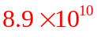
Practice 3 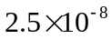= 0.000000025
Practice 4 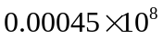 = 45000

Segment 3: Using the Properties of Exponents to Perform Operations with Scientific Notation

The Properties of Exponents make it relatively straightforward to perform operations with numbers written in scientific notation.
Perform the indicated operations. Express your answer in scientific notation.
Example 5 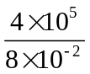 = 
Example 6 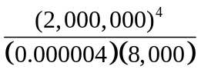= 

Example 7 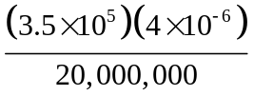 = 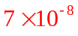

Practice 5 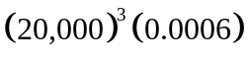 = 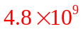

Practice 6   